### **Dystopia Design Challenge**

### 

### Task 1: Define Your Dystopian World

Our dystopian world takes inspiration from the hive cities of Warhammer 40,000; vast, crumbling megastructures where billions of souls are compressed into endless layers of concrete, steel, and suffocating smog. Once meant as monuments of human progress, these hives have decayed into prisons of poverty and oppression. Power lies firmly in the hands of a distant, theocratic authoritarian regime and its enforcers, who rule with absolute control and permit no dissent. In the upper spires, the elites hoard the little wealth and light that remain, while the underhives fester in darkness, disease, and scarcity. Daily life is defined by struggle, survival, and submission to an order that values obedience over dignity, all under the shadow of looming industrial cathedrals and unending war.

Task 2:

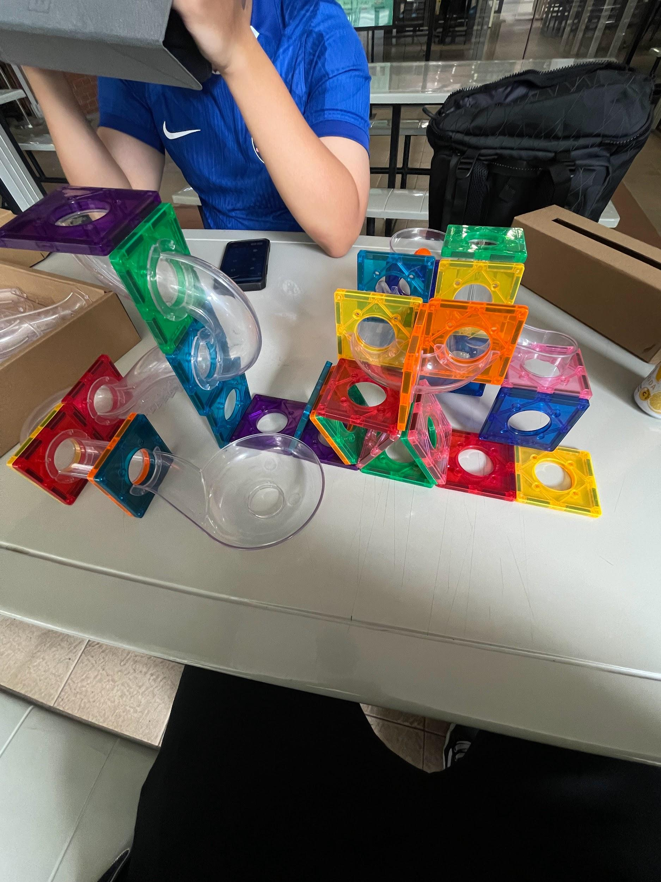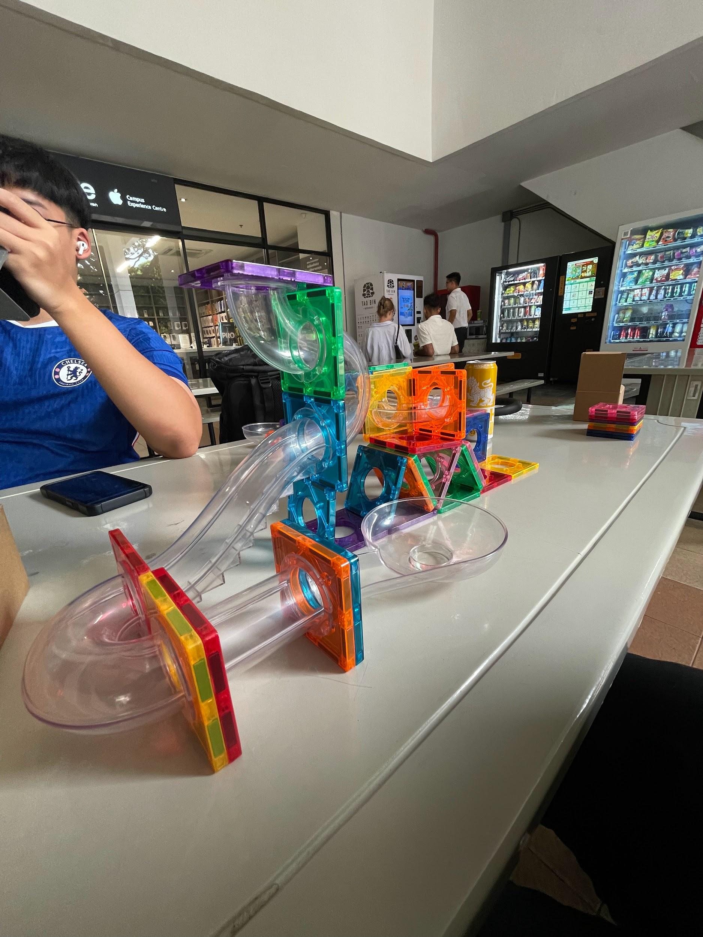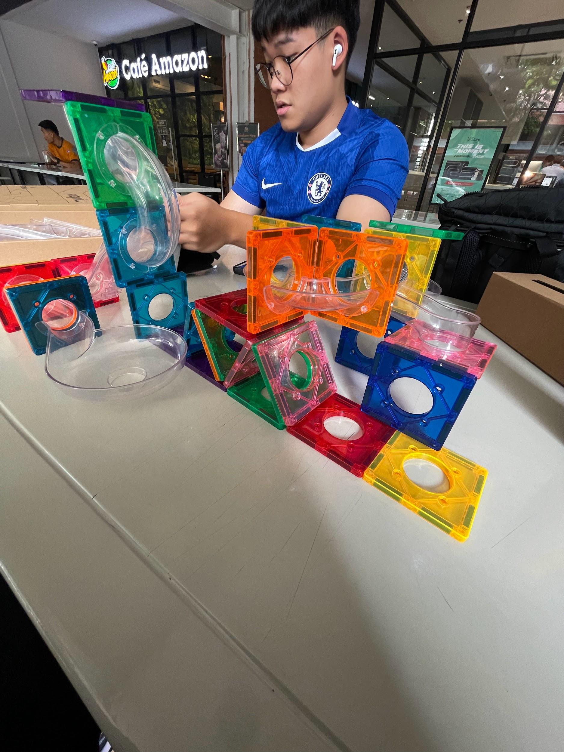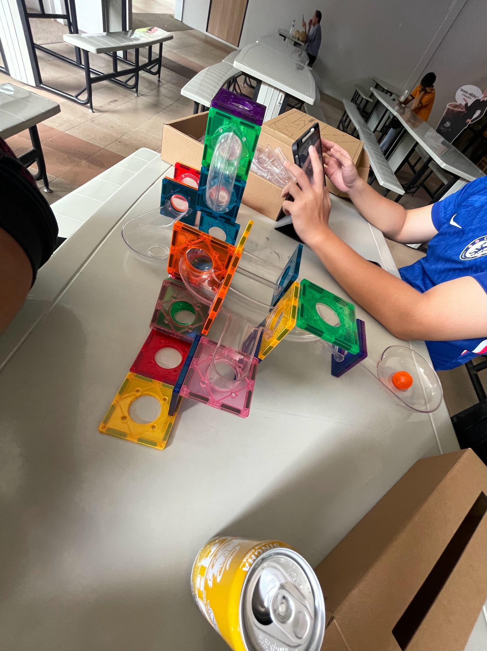

### Task 3: Prototype description

The context of the dystopia

* Within a hive world of the 41st millenium, communication and movement are critical for survival and rebellion alike. The labyrinthine architecture of the megastructure makes isolation a constant threat, while strict surveillance limits access to advanced technology. Our design imagines a grassroots system of connectivity born from the ingenuity of those trapped below the spires.

The purpose and function of the design

* Using the magnetic tiles to represent modular living units and walls, we constructed a fragmented but expandable structure resembling sections of the hive. Plastic tubes connect the tiles, allowing marbles to travel through them as symbols of messages, resources, or people moving discreetly. In the dystopian context, these tubes represent improvised communication lines or hidden passageways to the lower hives, where rebellion brews. The magnetic connections between tiles also stand for walkways, alleys, or precarious bridges used by residents to traverse their collapsing cityscape. Our design envisions a decentralized, low-tech infrastructure that allows information and resources to flow outside the control of ruling authorities.

Ethical questions or trade-offs

* The system raises difficult ethical questions. Should communication channels in a dystopia be used primarily for survival, smuggling food and medicine, or for rebellion, risking violent crackdowns from the enforcers above? The very design that empowers communities to connect can also expose them to surveillance if discovered, turning a tool of liberation into one of oppression. The trade-off lies in balancing secrecy with solidarity: how much can be risked in the name of freedom, and who ultimately decides?

### Task 4: Reflection on designs during times of crisis

Design in times of crisis is a double-edged sword. It can oppress just as easily as it can empower. When monopolized by those in power, design becomes a mechanism of control, embedding surveillance, restriction, and dependency into the daily lives of ordinary people. Walls, gates, and systems of exclusion are all “designs” that maintain inequality and submission. Yet in the hands of the oppressed, design transforms into a tool of resilience and agency. Even small, improvised structures such as hidden passages, coded signals, or makeshift shelters, become acts of resistance that restore dignity and hope. Our prototype illustrates this tension: the same network that is the backbone of rebellion could just as easily be turned against its makers. Thus, design is not neutral. In crisis, it reflects the struggle between domination and liberation, embodying both the potential for oppression and the promise of empowerment.